Image | 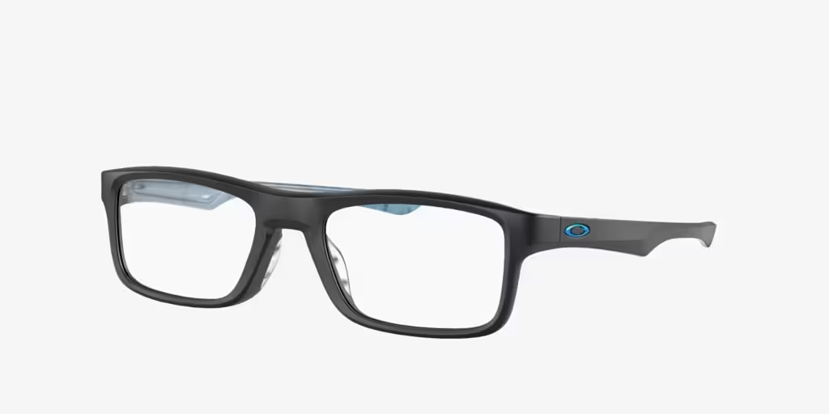
Brand | MICHEAL KORS
Model Name | OX8081 PLANK
Price | RS
PRODUCT DETAILS

